Replacement of domestic items relief
Replacement of domestic items (RDI) relief, which replaced the previous Wear and Tear Allowance, allows residential landlords to claim tax relief for replacements of certain items in the property, known as domestic items.

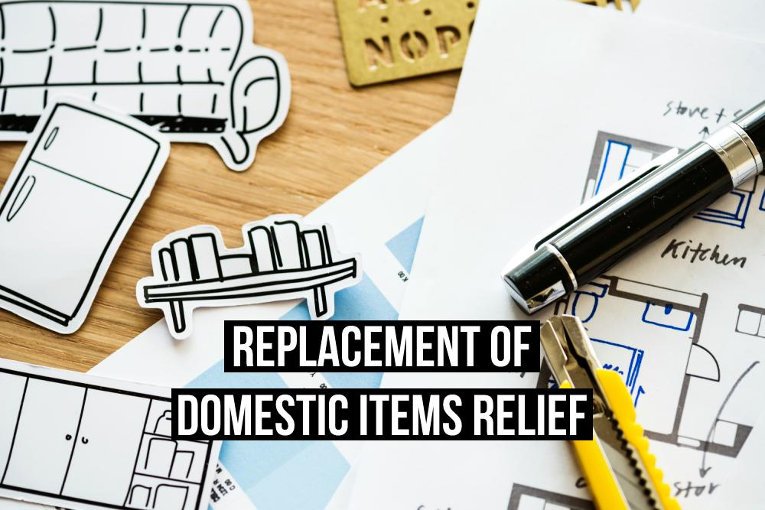

What are domestic items?
Domestic items include:

- Moveable furniture, such as beds and wardrobes
- Furnishings, such as curtains, carpets and linen
- Appliances, such as fridges, freezers and TVs
- Kitchenware, such as cutlery and crockery

Domestic items do not include any items that become part of the house, for instance, fitted appliances and bathroom fixtures.

Conditions for relief
A deduction cannot be claimed if Rent a Room relief has been claimed in respect of the property.

In order for a cost to be considered a replacement, the following 4 conditions must be met:

- The individual or company must run a property-letting business.
- An old domestic item in the house-let is removed and replaced with a new domestic item, for sole use by the tenant.
- The domestic item being replaced must be required for the property business to function. If it is not a necessity, the relief cannot be claimed.
- You have not claimed capital allowances on the cost of the new item.

If all 4 conditions have been met, then you can claim a deduction for the cost of the new domestic item.

New domestic items
The cost of replacing an item is only deductible when it's replaced with one that is of similar quality.

If the replacement was bought new, this doesn’t automatically make it a higher quality or standard.

For instance, a brand new fridge that cost £400 is not an improvement over a 10-year-old fridge that cost £400 at the time of purchase. In this case, the cost of the new fridge can be deducted.

If the new fridge is of far superior quality and is much more expensive than the original item, RDI relief can be claimed, but only on the notional cost of buying an equivalent item.

